You have been asked to:
- In Power BI Desktop, connect to AdventureWorks Sales Data.xlsx.

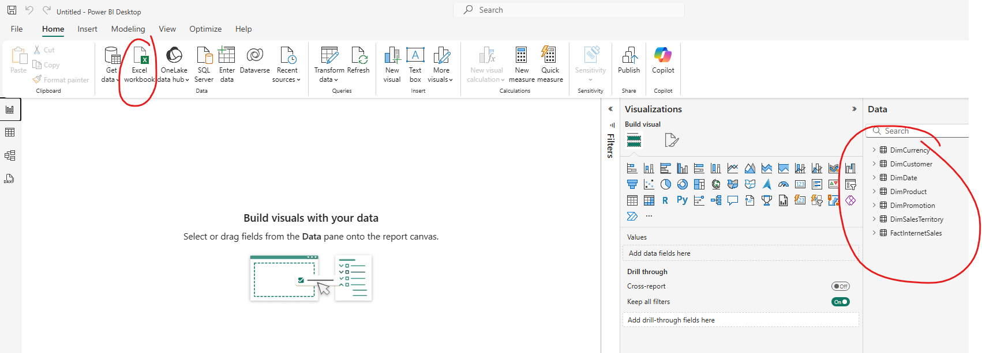

- Import DimCurrency, DimCustomer, DimDate, DimProduct, DimPromotion, DimSalesTerritory, and FactInternetSales worksheets.

- Create a new relationship between the FactInternetSales table’s OrderDateKey column and the DateKey column in DimDate. Set the cardinality as Many to One (*:1), the cross-filter direction as Single, and make this relationship Active.
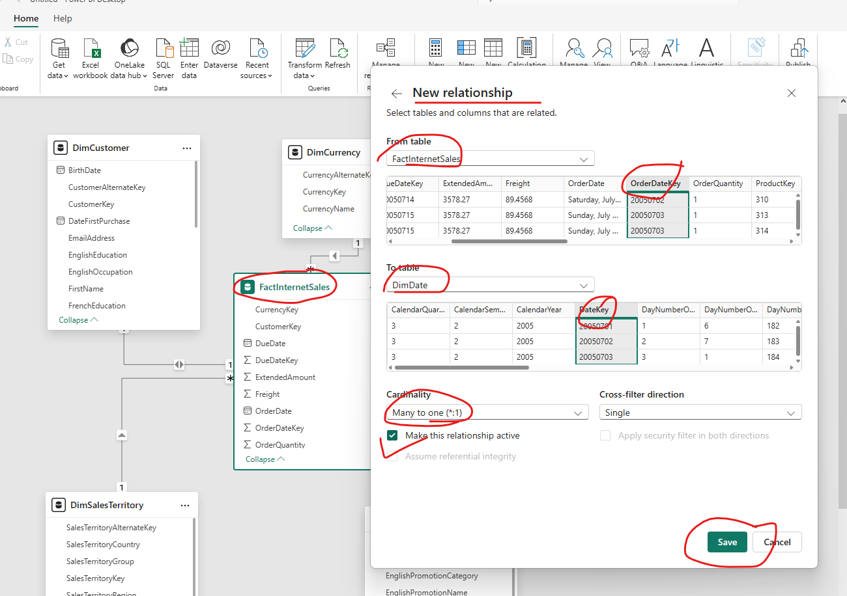

- Create a relationship from FactInternetSales [DueDateKey] to DimDate [DateKey].

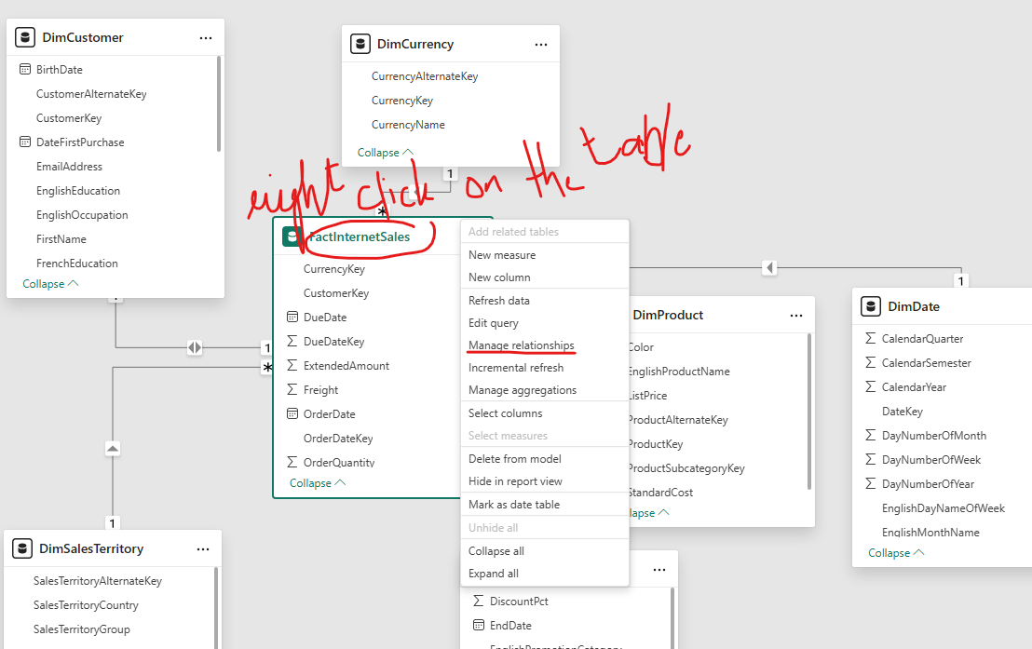

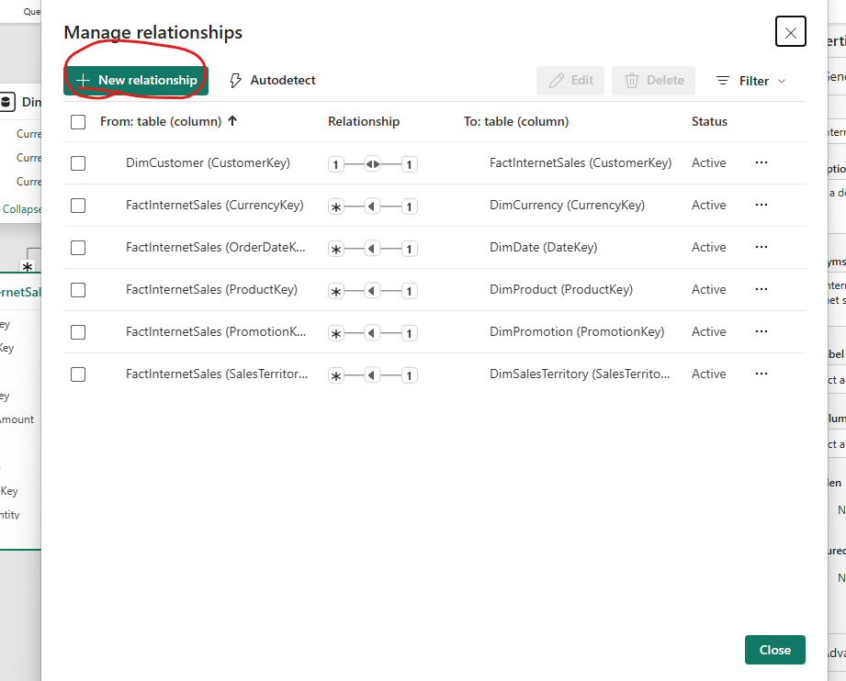
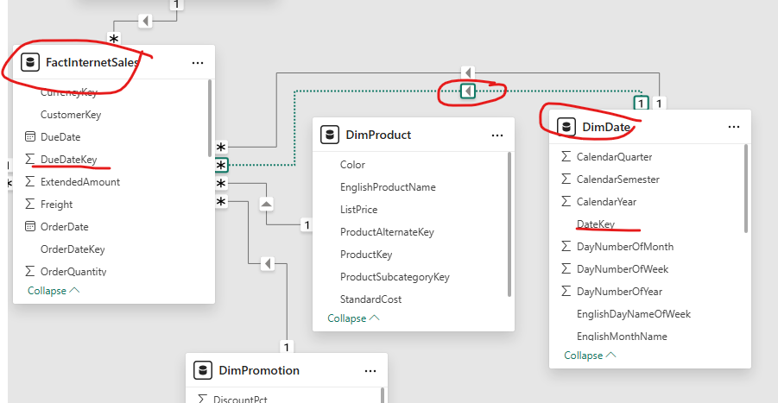

- Create a relationship between FactInternetSales [ShipDateKey] and DimDate [DateKey].
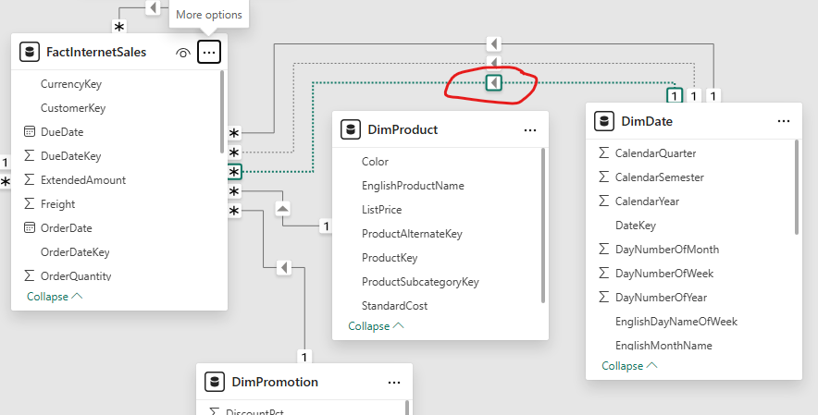

- In Power BI Desktop, load the DimProductCategory and DimProductSubcategory data from the AdventureWorks Product Categories.xlsx file.
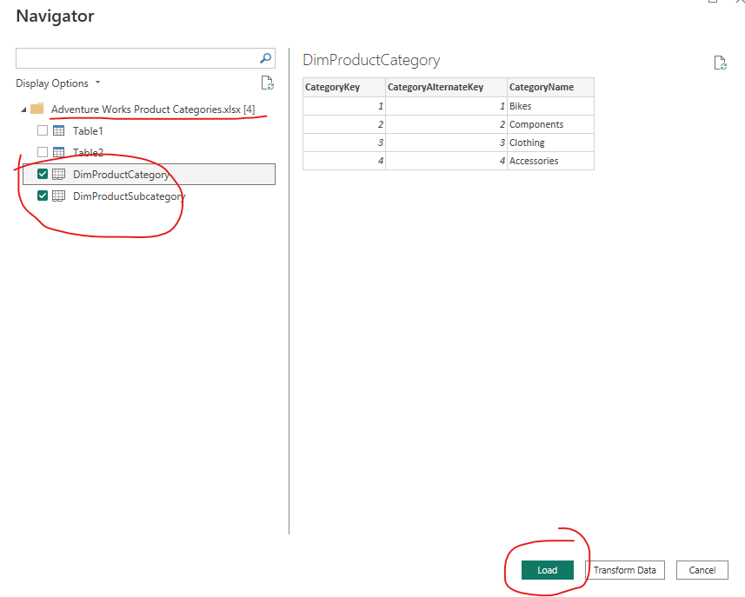

- Delete the relationship between DimProductCategory and DimProductSubcategory.
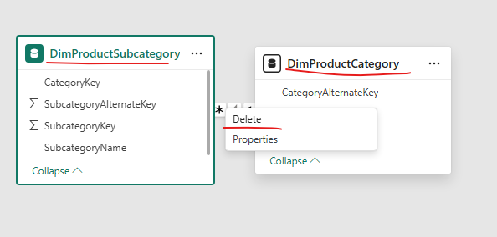

- Create a Many to One (*:1) between DimProductSubcategory [CategoryKey] and DimProductCategory [CategoryKey] and make the cross-filter direction to both.
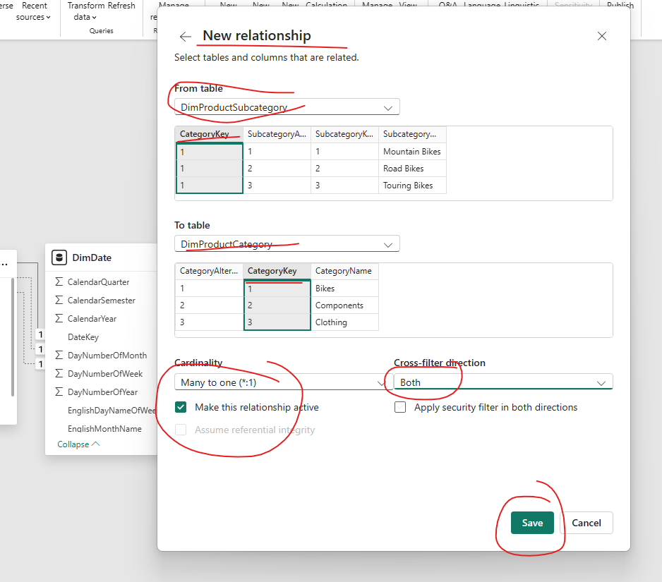
- Create a Many to One (*:1) between DimProduct [ProductSubcategoryKey] and DimProductSubcategory [SubcategoryKey] and make the cross-filter direction to both
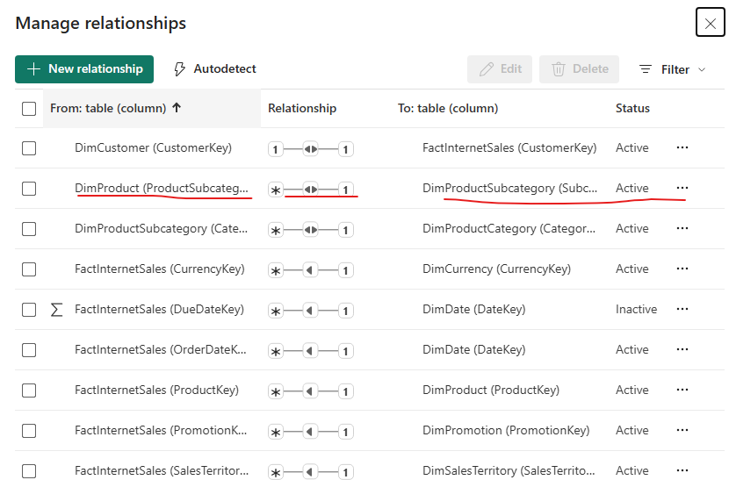
j) Add a calculated column named IncomeStatus to the DimCustomer table based on the Yearly Income column. Income should be classified as follows:
• Lower than 25,000: Lower Income
• Between 25,000 and 60,000: Middle Income
• Between 60,000 and 100,000: Higher Income
• 100,000 and upward: Very High Income.
Dax Query:
IncomeStatus = IF(DimCustomer[YearlyIncome] < 25000, "Lower Income",IF(DimCustomer[YearlyIncome] >= 25000 && DimCustomer[YearlyIncome] <= 60000, "Middle Income",IF(DimCustomer[YearlyIncome] > 60000 && DimCustomer[YearlyIncome] < 100000, "Higher Income","Very High Income")))

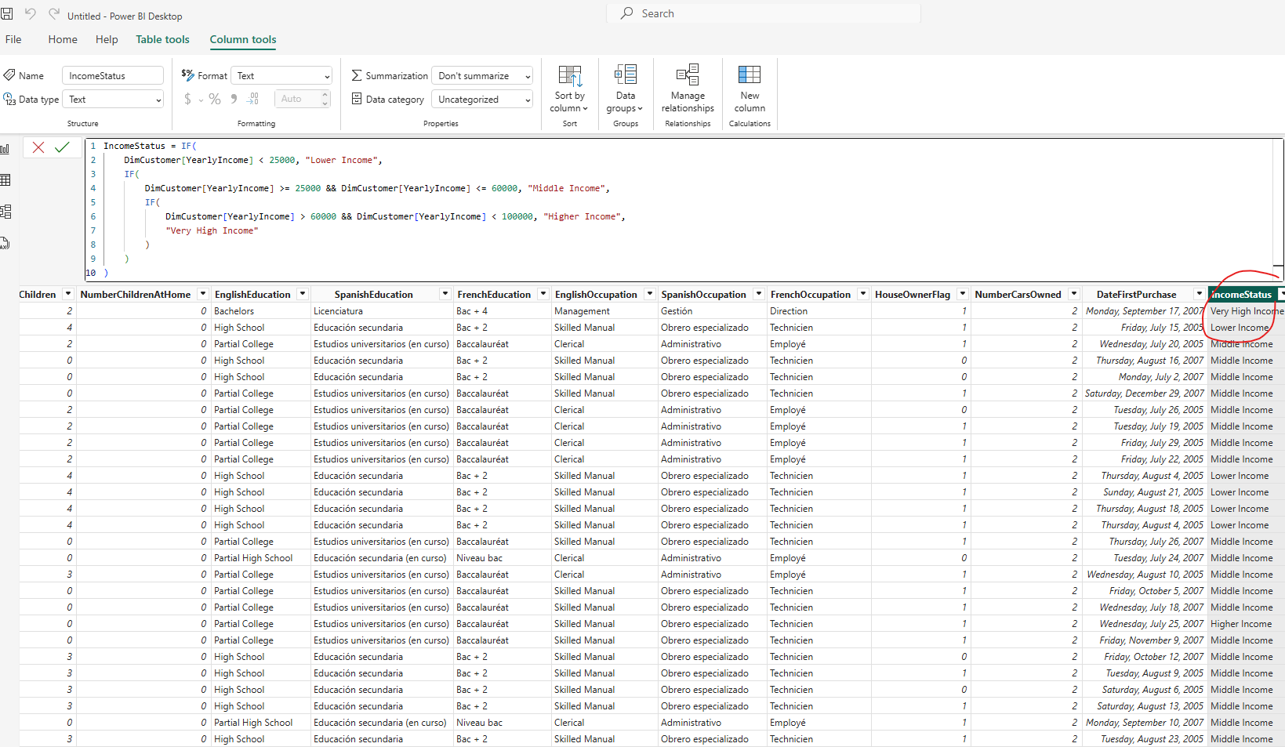

- Add a calculated column named DaysSinceFirstPurchase to the DimCustomer table to show the number of days since a customer made the first purchase.
Dax Query: DaysSinceFirstPurchase =
DATEDIFF(DimCustomer[DateFirstPurchase],TODAY(),DAY)

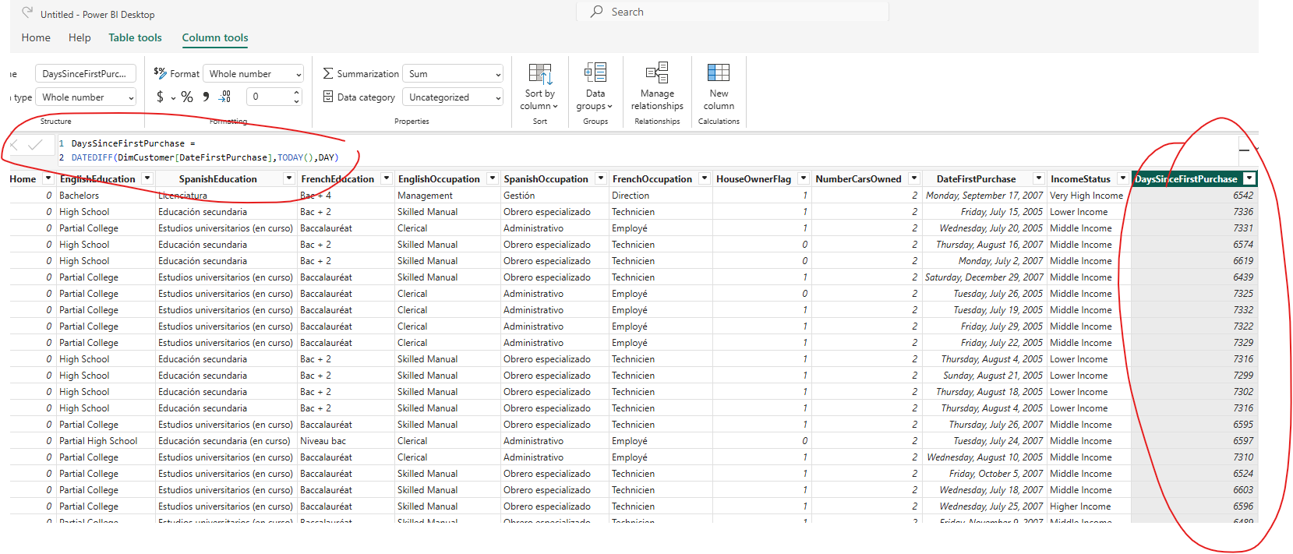
- Add a calculated column named FullName to DimCustomer, which concatenates the FirstName and the LastName.
Dax Query: Full Name = DimCustomer[FirstName] & " " & DimCustomer[LastName]
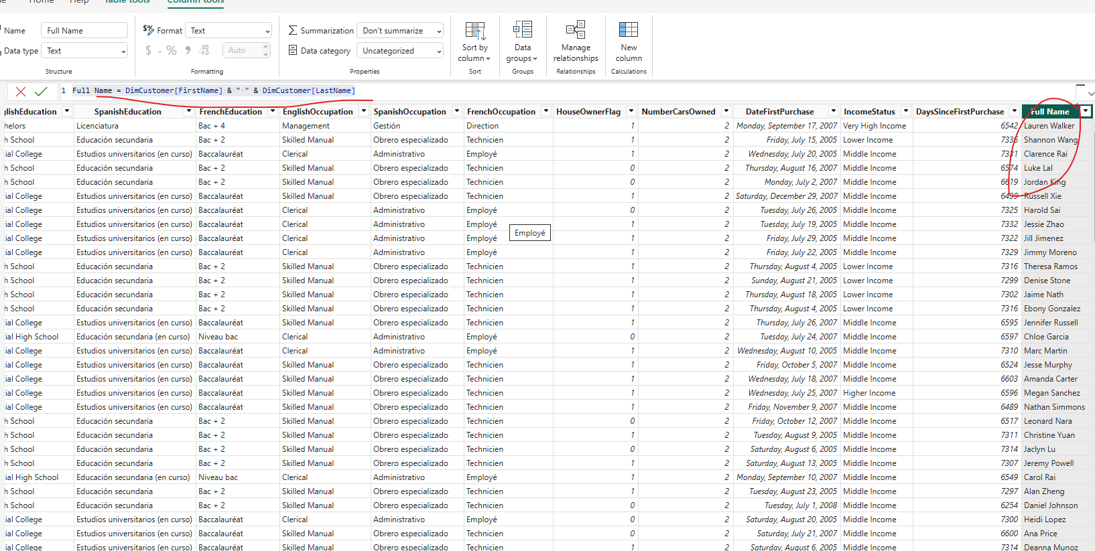

- Add a calculated column named MaleFemale to DimCustomer, which converts the values of the Gender column to Male or Female.
Dax Query: MaleFemale = IF(DimCustomer[Gender] = "M", "Male", IF(DimCustomer[Gender] = "F", "Female", "Other"))

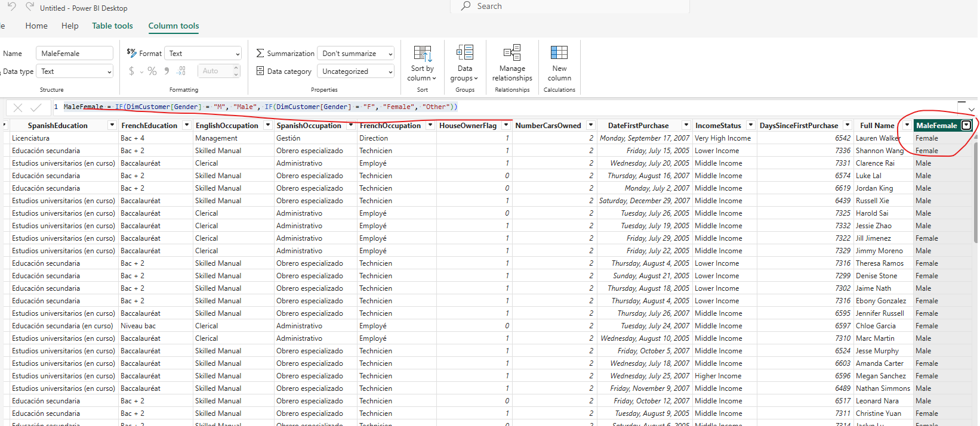

- Add a calculated column to DimCustomer, called Relationship, which converts the value of the MaritalStatus column to Married or Single.
Query: Relationship = IF(DimCustomer[MaritalStatus] = "M", "Married", "Single")
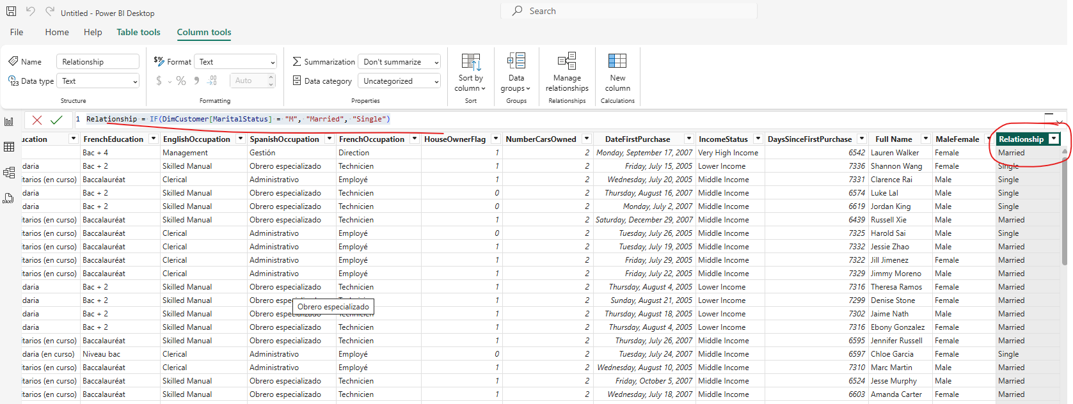

- Add a calculated column called MainCategory to the DimProductSubcategory table, which gets the category name from DimProductCategory.
Query:
MainCategory = RELATED(DimProductCategory[CategoryName])
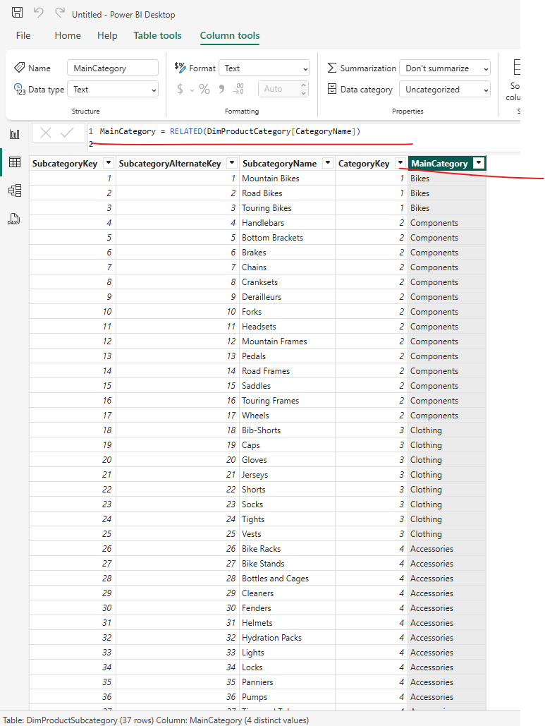

- Add a calculated column called PromotionLengthDays to the DimPromotion table, which is the difference between StartDate and EndDate.
Query: PromotionLengthDays =DATEDIFF(DimPromotion[StartDate],DimPromotion[EndDate],DAY)
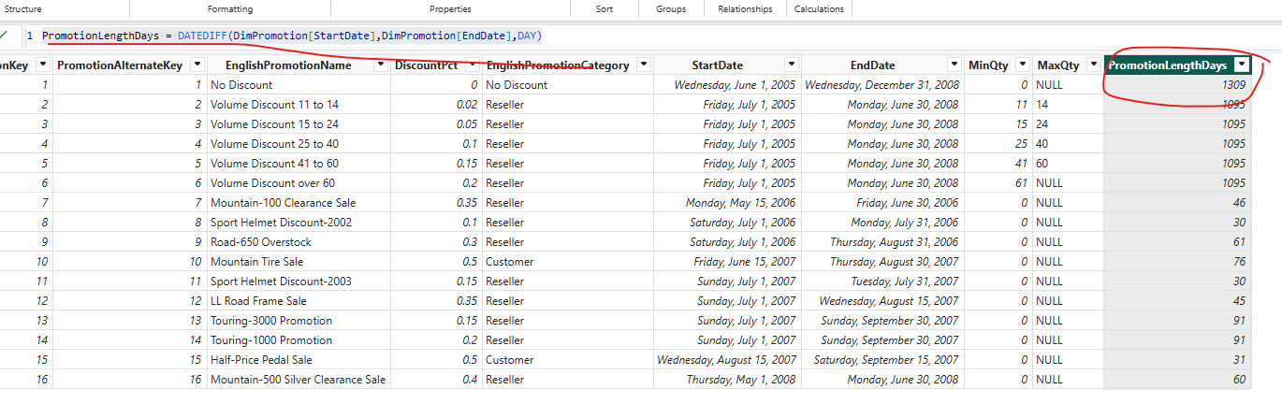

- Add a calculated column called Profit to FactInternetSales, and show the difference between UnitPrice and ProductStandardCost formatted as currency.
Query: Profit = FactInternetSales[UnitPrice]-FactInternetSales[ProductStandardCost]
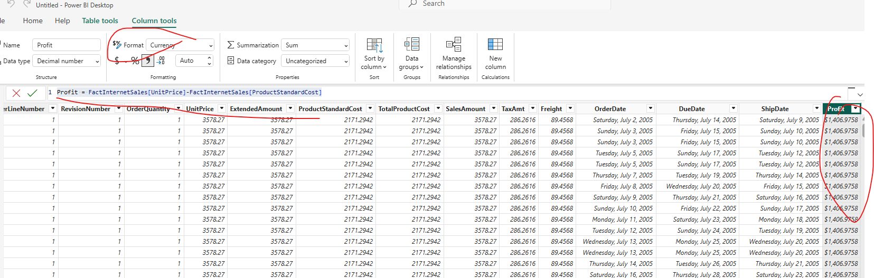

- Save the changes, and close Power BI Desktop

Insights requested for career transition from IT to Molecular Biology!
Hi ,
I hope you are doing well. I’m exploring a transition from my career in IT into the field of molecular biology and biomedical research, with a special interest in cancer and nutrition. My goal is to study how molecular and genetic changes in the human body correlate with nutrition, malnutrition, and chronic disease.
Although my background is in engineering and management, and I currently have a stable IT career, I’m seeking a path that offers deeper purpose and impact. I’m motivated to learn, but I want to approach this transition with a realistic view of the challenges and opportunities ahead.
I’d greatly value your perspective on:
- The key challenges a non-biology professional might face when entering this field.
- The timeframe typically required to establish a career after formal training.
- Whether such a transition is worthwhile and sustainable in the long run, including its impact on finances.
Your guidance and insights would mean a lot as I make this decision thoughtfully.
Thank you for your time!
Best regards,
Pritu Thakur

